1. Using HTML & CSS – Design Google Home page.

Google.html

<!DOCTYPE html>

<html lang="en">

  <head>

    <meta charset="UTF-8" />

    <meta http-equiv="X-UA-Compatible" content="IE=edge" />

    <meta name="viewport" content="width=device-width, initial-scale=1.0" />

    <title>Google</title>

    <style>

      @import url("https://fonts.googleapis.com/css2?family=Poppins&display=swap");

      body {

        font-family: "Poppins", sans-serif;

      }

      .corner {

        background-image: url("./bg.jpg");

        background-repeat: no-repeat;

        background-size: cover;

      }

      .header {

        display: flex;

        justify-content: center;

        justify-items: center;

        flex-direction: column;

        text-align: center;

        height: 100vh;

      }

      input {

        width: 10rem;

        height: 2rem;

        padding: 5px;

        border: 1px solid rgba(0, 0, 0, 0.164);

        cursor: pointer;

      }

      .mail {

        display: flex;

        flex-direction: row;

        color: aliceblue;

        justify-content: right;

      }

      #a {

        font-size: small;

        margin: 5px;

        padding-top: 20px;

        padding-right: 20px;

      }

    </style>

  </head>

  <body>

    <div class="corner">

      <div class="mail">

        <div id="a">Gmail</div>

        <div id="a">Images</div>

      </div>

      <div class="header">

        <div

          style="

            font-size: 70px;

            margin-bottom: 30px;

            color: rgb(243, 241, 239);

          "

        >

          Google

        </div>

        <div>

          <input

            style="

              border-radius: 50px;

              width: 30rem;

              padding: 6px;

              margin-bottom: 15px;

              border: 1px solid rgba(0, 0, 0, 0.212);

            "

            type="text"

            placeholder="Search Google or type a URL"

          />

        </div>

        <div>

          <input type="button" value="Google Search" />

          <input type="button" value="I'am feeling Lucky" />

        </div>

      </div>

    </div>

  </body>

</html>

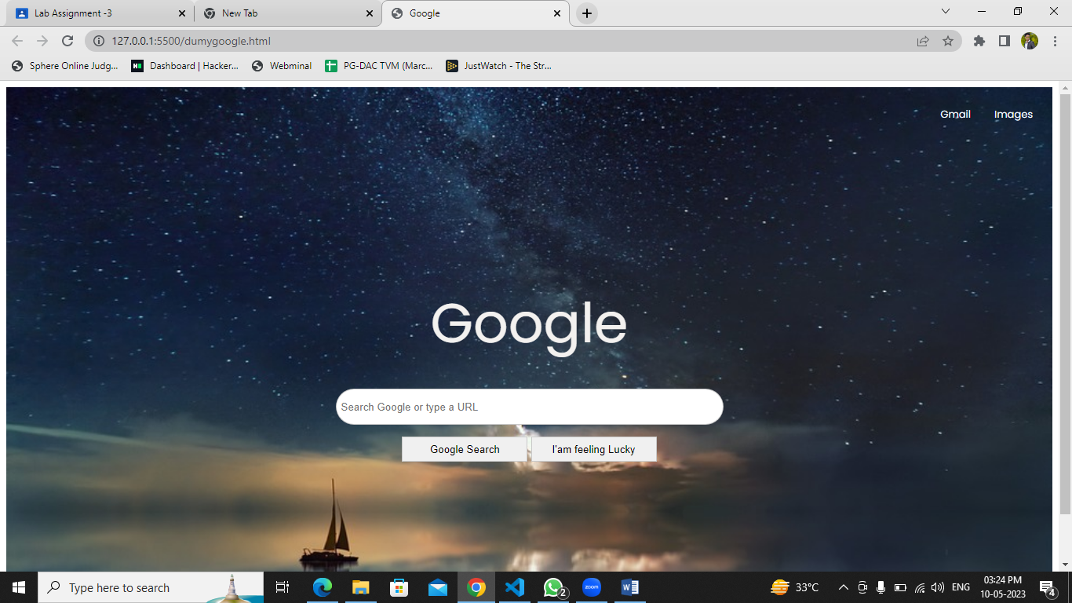

2. Using HTML & CSS – Create a colourful Resume.

<!DOCTYPE html>

<html lang="en">

  <head>

    <meta charset="UTF-8" />

    <meta http-equiv="X-UA-Compatible" content="IE=edge" />

    <meta name="viewport" content="width=device-width, initial-scale=1.0" />

    <title>Resume</title>

    <style>

      @import url("https://fonts.googleapis.com/css2?family=Poppins&display=swap");

      body {

        background-color: #dbf9fc7c;

        color: #333;

        font-family: "Poppins", sans-serif;

        display: inline-block;

      }

      h {

        gap: 1px;

        text-align: justify;

      }

      h1 {

        text-decoration: underline rgb(3, 215, 243);

        text-align: center;

      }

      h3 {

        text-decoration: underline rgba(0, 0, 0, 0.521);

        background-color: rgba(243, 202, 202, 0.603);

      }

      h4 {

        margin-top: 0;

        margin-bottom: 0;

      }

      #info {

        text-align: center;

      }

      #header {

        background-color: rgba(51, 222, 228, 0.356);

      }

    </style>

  </head>

  <body>

    <div id="header">

      <h1>Paresh Dhopat</h1>

      <div id="info">

        <h4 style="text-align: center">

          Email : pareshdhopat12@gmail.com | Contact : 8097543222 | Location :

          Mumbai

        </h4>

      </div>

    </div>

    <hr />

    <h3>Objective</h3>

    <p>

      To become a successful expert in the field of Information Technology by

      channelizing my technical knowledge and skills to ensure personal and

      professional growth and to contribute to the prosperity of the

      organization.

    </p>

    <hr />

    <h3>Education</h3>

    <h4>Bachelor of Engineering (B.E) Computer Science & Engineering</h4>

    <p style="width: auto">St John College of Engineering and Technology</p>

    <p>Duration : 2016-2019 CGPA: 6.50/10</p>

    <h4>Diploma, Computer Science & Engineering</h4>

    <p>Shri Bhagubhai Mafatlal Polytechnic</p>

    <p>Duration 2012 - 2016 Percentage: 60.27%</p>

    <h4>Secondary (X)</h4>

    <p>Vidyanidhi Vrajlal Parekh High School (SSC Board)</p>

    <p>Year of completion: 2012 Percentage: 76.91%</p>

    <hr />

    <h3>Projects</h3>

    <h4>Voice Bot for Agricultural</h4>

    <p>Duration Jan 2019 - Apr 2019</p>

    <p>

      Farmers are not aware of the new emerging technologies and techniques So

      VoiceBot will help to increase their knowledge. We have built a system

      where the framers can resolve their queries about agriculture by using

      their phones.

    </p>

    <h4>Voice Recognition System</h4>

    <p>Duration Jan 2016 - Apr 2016</p>

    <p>

      This Software allows user to use their voice to control the computer. For

      example, for a task to run a particular file, we simply say "run

      (filename)". The software will automatically detect the file with that

      name and do the task mentioned.

    </p>

    <hr />

    <div class="skills">

      <h3>Skills</h3>

      <ul type="circle">

        <li>Java</li>

        <li>HTML</li>

        <li>DBMS</li>

        <li>React Js</li>

        <li>node Js</li>

        <li>Mongo DB</li>

      </ul>

    </div>

    <h3>Declaration</h3>

    <p>

      I hereby confirm and verify all the facts mentioned above and I hold the

      responsibility of their authenticity and correctness.

    </p>

    <h5 style="text-align: right">Thank you</h5>

    <h5 style="text-align: right">Paresh Dhopat</h5>

    <a href="./registration.html">Move back to registration</a>

  </body>

</html>

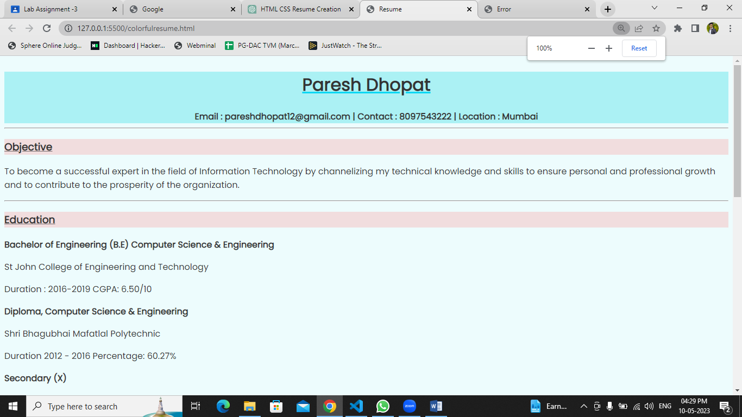

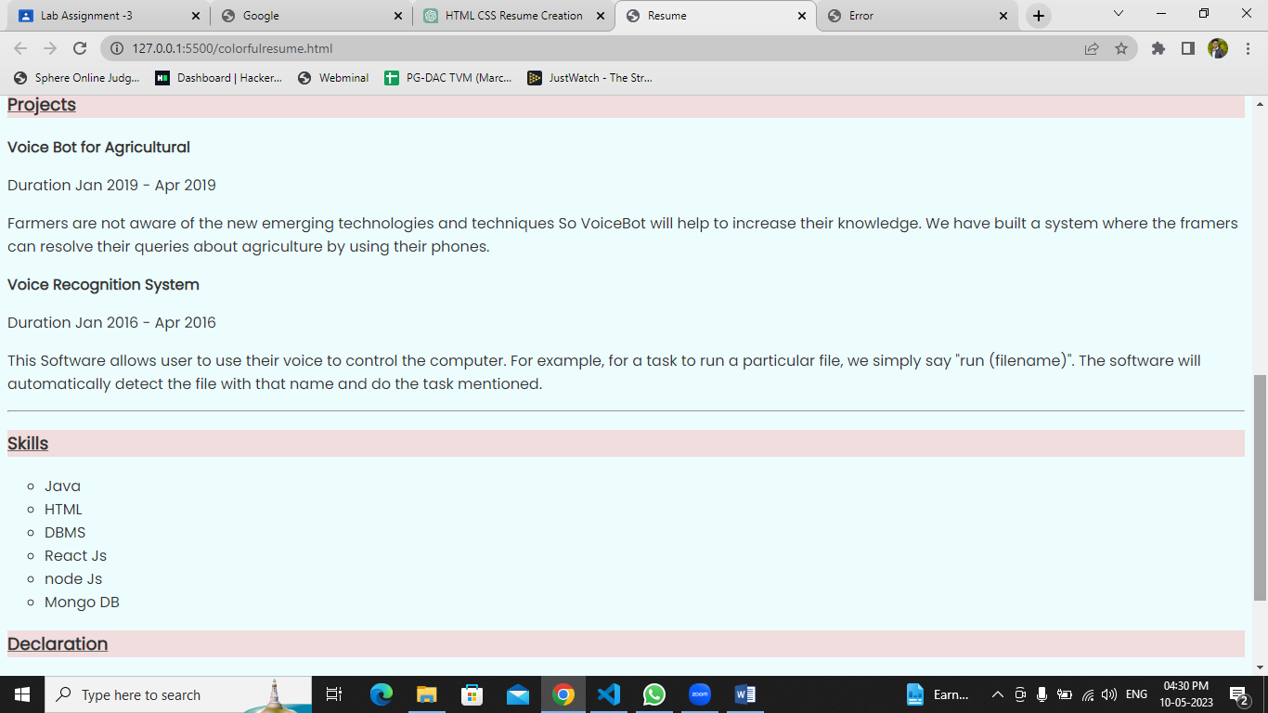

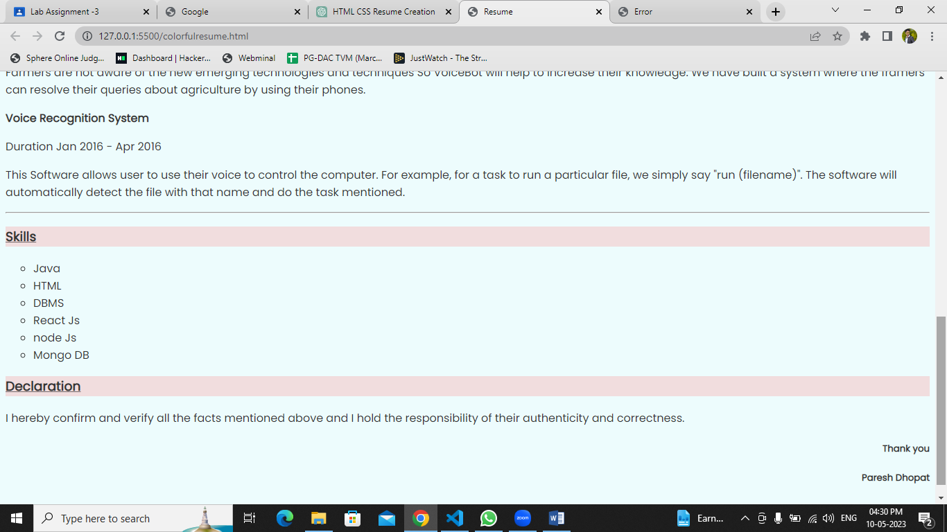

3. Using HTML & CSS Style - design a Book Library [or image Library ] it will

show different books images collection and also create a button to set buying

price of books.

<!DOCTYPE html>

<html lang="en">

  <head>

    <meta charset="UTF-8" />

    <meta http-equiv="X-UA-Compatible" content="IE=edge" />

    <meta name="viewport" content="width=device-width, initial-scale=1.0" />

    <title>Book Library</title>

    <style>

      @import url("https://fonts.googleapis.com/css2?family=Kanit&display=swap");

      body {

        font-family: "Kanit", sans-serif;

        background-color: aquamarine;

        background-image: url("https://images.unsplash.com/photo-1524995997946-a1c2e315a42f?ixlib=rb-4.0.3&ixid=MnwxMjA3fDB8MHxwaG90by1wYWdlfHx8fGVufDB8fHx8&auto=format&fit=crop&w=870&q=80");

        background-repeat: no-repeat;

        background-attachment: fixed;

        background-size: 100% 100%;

      }

      .container {

        display: flex;

        justify-content: center;

        text-align: center;

        flex-wrap: wrap;

      }

      .section {

        background-color: rgba(255, 135, 135, 0.295);

        opacity: 1px;

        width: 300px;

        height: 300px;

      }

      .section img {

        width: 270px;

        height: 205px;

        transition: transform 0.2s;

        margin: 0 auto;

      }

      .section img :hover {

        transform: scale(1);

      }

      .section #button {

        border: 1px solid rgba(0, 0, 0, 0.404);

        border-radius: 10px;

        width: 5rem;

        padding: 5px;

        cursor: pointer;

        background-color: #1f1d1cf6;

        border: none;

        color: rgb(253, 252, 252);

        text-align: center;

        font-size: 14px;

        margin-top: 1px;

        opacity: 0.7;

        transition: 0.3s;

      }

      #button:hover {

        opacity: 1;

      }

      h1 {

        background-color: rgba(255, 81, 81, 0.363);

        color: rgb(10, 10, 10);

        text-align: center;

        border: 1px solid rgba(158, 120, 120, 0.479);

      }

    </style>

  </head>

  <body>

    <h1>Welcome to book store</h1>

    <div class="container">

      <div class="section">

        <img

          src="https://images.unsplash.com/photo-1592496431122-2349e0fbc666?ixlib=rb-4.0.3&ixid=MnwxMjA3fDB8MHxwaG90by1wYWdlfHx8fGVufDB8fHx8&auto=format&fit=crop&w=1512&q=80"

        />

        <p>Price : 200₹</p>

        <input id="button" type="button" value="Add to card" />

      </div>

      <div class="section">

        <img

          src="https://images.unsplash.com/photo-1589829085413-56de8ae18c73?ixlib=rb-4.0.3&ixid=MnwxMjA3fDB8MHxwaG90by1wYWdlfHx8fGVufDB8fHx8&auto=format&fit=crop&w=912&q=80"

        />

        <p>Price : 300₹</p>

        <input id="button" type="button" value="Add to card" />

      </div>

      <div class="section">

        <img

          src="https://images.unsplash.com/photo-1629992101753-56d196c8aabb?ixlib=rb-4.0.3&ixid=MnwxMjA3fDB8MHxzZWFyY2h8Nnx8Ym9vayUyMGNvdmVyfGVufDB8fDB8fA%3D%3D&auto=format&fit=crop&w=500&q=60"

        />

        <p>Price : 500₹</p>

        <input id="button" type="button" value="Add to card" />

      </div>

      <div class="section">

        <img

          src="https://images.unsplash.com/photo-1641154748135-8032a61a3f80?ixlib=rb-4.0.3&ixid=MnwxMjA3fDB8MHxzZWFyY2h8OXx8Ym9vayUyMGNvdmVyfGVufDB8fDB8fA%3D%3D&auto=format&fit=crop&w=500&q=60"

        />

        <p>Price : 250₹</p>

        <input id="button" type="button" value="Add to card" />

      </div>

      <div class="section">

        <img

          src="https://images.unsplash.com/photo-1633477189729-9290b3261d0a?ixlib=rb-4.0.3&ixid=MnwxMjA3fDB8MHxwaG90by1wYWdlfHx8fGVufDB8fHx8&auto=format&fit=crop&w=722&q=80"

        />

        <p>Price : 250₹</p>

        <input id="button" type="button" value="Add to card" />

      </div>

      <div class="section">

        <img

          src="https://images.unsplash.com/photo-1612969308146-066d55f37ccb?ixlib=rb-4.0.3&ixid=MnwxMjA3fDB8MHxzZWFyY2h8MTV8fGJvb2slMjBjb3ZlcnxlbnwwfHwwfHw%3D&auto=format&fit=crop&w=500&q=60"

        />

        <p>Price : 600₹</p>

        <input id="button" type="button" value="Add to card" />

      </div>

      <div class="section">

        <img

          src="https://images.unsplash.com/photo-1521123845560-14093637aa7d?ixlib=rb-4.0.3&ixid=MnwxMjA3fDB8MHxwaG90by1wYWdlfHx8fGVufDB8fHx8&auto=format&fit=crop&w=870&q=80"

        />

        <p>Price : 267₹</p>

        <input id="button" type="button" value="Add to card" />

      </div>

      <div class="section">

        <img

          src="https://images.unsplash.com/photo-1535398089889-dd807df1dfaa?ixlib=rb-4.0.3&ixid=MnwxMjA3fDB8MHxwaG90by1wYWdlfHx8fGVufDB8fHx8&auto=format&fit=crop&w=464&q=80"

        />

        <p>Price : 877₹</p>

        <input id="button" type="button" value="Add to card" />

      </div>

      <div class="section">

        <img

          src="https://images.unsplash.com/photo-1535398089889-dd807df1dfaa?ixlib=rb-4.0.3&ixid=MnwxMjA3fDB8MHxwaG90by1wYWdlfHx8fGVufDB8fHx8&auto=format&fit=crop&w=464&q=80"

        />

        <p>Price : 877₹</p>

        <input id="button" type="button" value="Add to card" />

      </div>

      <div class="section">

        <img

          src="https://images.unsplash.com/photo-1610882648335-ced8fc8fa6b6?ixlib=rb-4.0.3&ixid=MnwxMjA3fDB8MHxzZWFyY2h8MzJ8fGJvb2slMjBjb3ZlcnxlbnwwfHwwfHw%3D&auto=format&fit=crop&w=500&q=60"

        />

        <p>Price : 677₹</p>

        <input id="button" type="button" value="Add to card" />

      </div>

      <div class="section">

        <img

          src="https://images.unsplash.com/photo-1633580969859-ee2aa7fd2648?ixlib=rb-4.0.3&ixid=MnwxMjA3fDB8MHxzZWFyY2h8MzR8fGJvb2slMjBjb3ZlcnxlbnwwfHwwfHw%3D&auto=format&fit=crop&w=500&q=60"

        />

        <p>Price : 175₹</p>

        <input id="button" type="button" value="Add to card" />

      </div>

      <div class="section">

        <img

          src="https://images.unsplash.com/photo-1641261689151-7f818366e684?ixlib=rb-4.0.3&ixid=MnwxMjA3fDB8MHxzZWFyY2h8NDV8fGJvb2slMjBjb3ZlcnxlbnwwfHwwfHw%3D&auto=format&fit=crop&w=500&q=60"

        />

        <p>Price : 590₹</p>

        <input id="button" type="button" value="Add to card" />

      </div>

    </div>

  </body>

</html>

